**Changes in TBDR v1.1**

* Variant data with multiple data sources will be displayed as below.
* Modified pagination feature with more options. This is implemented for both ***Variants*** and ***Search*** menu items.

1. You can now chose number of records to be displayed on the page. (ex: 10,25,50 or 100 records)
2. A simple search box to type in any column value and retrieve the result.
3. Shows total number of records and the current view.
4. More organized pagination view.

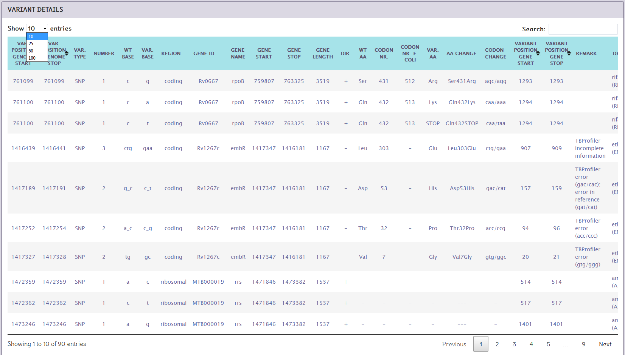 (1)

(2)

(4)

(3)